1. **Introduction**

* **SHORT AND LONG RANGE ORDER**

**Order:** Presence of some symmetry or correlation in a many-particle system.

**Short-range order:** It exists till the first or second-nearest neighbors of an atom. It implies non dense, random packing (fig.1).

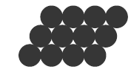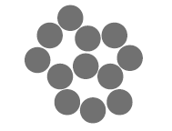

*Figure 1: Short-range order of materials.* *Figure 2: Long-range order of materials.*

**Long-range order:** It exists over long distances. It implies dense, regular packing (fig.2).

Dense, regular-packed structures having long-range tend to have lower energy.

* + - ***Classification Of Matter On The Basis Of Order***

Materials can be classified on the basis of order. Gases do not have any order. This is followed by amorphous materials which has only short-range order. Next in line are liquid crystals which have short and long range order in small volumes.

Finally, long range order is observed in crystalline materials.

They are of two types: **single crystal and polycrystalline**.

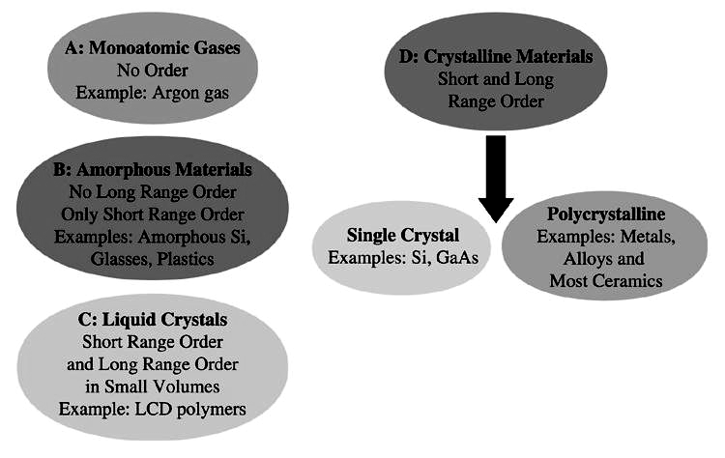.

*Figure 3: Classification of materials on the basis of order.*

* + - ***Difference Between Single And Poly-Crystals***

**Single crystal**: A **single crystal** or monocrystalline solid is a material in which the **crystal** lattice of the entire sample is continuous and unbroken to the edges of the sample, with no grain boundaries (fig.4a).

The properties of a single crystal vary with direction. This is termed as anisotropy**.** For eg. the modulus of elasticity (E) in BCC iron (fig.4b). The values of modulus of elasticity in BCC iron is different along the edge of the cube and along the body diagonal of the cube giving rise to anisotropy.

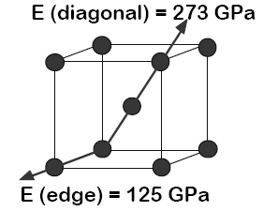

(b)

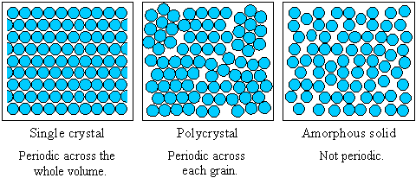

(a)

*Figure 4: (a) Pictorial representation of a single crystal. (b) Modulus of elasticity (E) in BCC iron.*

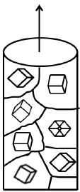**Poly-crystal:** It is comprised of many small randomly oriented crystals or grains. The properties of a polycrystalline material may/may not vary with direction, depending on degree of **texture (orientation)**. If the grains are randomly oriented, then the properties are same along all directions i.e., isotropic. For eg. the bulk modulus of randomly oriented polycrystalline iron is 210 GPa along all directions (fig.5). However, if all the grains are oriented in a single direction, then the properties will be anisotropic.

*Figure 5:*

*Polycrystalline sample of non-oriented iron.*

* + **LATTICE, BASIS, CRYSTAL STRUCTURE**

**Space Lattice**: A translational periodic arrangement of **lattice points.** Each lattice point in a lattice has identical neighborhood of other lattice points.

**Bravais Lattice**: Bravais lattice, studied by [Auguste](https://en.wikipedia.org/wiki/Auguste_Bravais) [Bravais](https://en.wikipedia.org/wiki/Auguste_Bravais) ([1850](https://en.wikipedia.org/wiki/Bravais_lattice)), is an infinite array of discrete points in three dimensional space generated by a set of discrete translation operations described by:

***R = n1a1 + n2a2+n3a3***

where ***ni*** are any integers and ***a****i* are known as the primitive vectors which lie in different directions and span the lattice. For any choice of position vector **R**, the lattice looks exactly the same.

**Motif or Basis:** An atom ora group of atoms associated with each lattice point.

**Crystal:** **A translational periodic arrangement of atoms. It is made up of lattice and basis.**

Types of crystals

* + - ***Unit Cell and Primitive Cell***

**Unit Cell** The smallest building block of a crystal, consisting of atoms, ions, or molecules, whose  geometric arrangement defines the symmetry and structure of the entire crystal lattice and whose repetitive translation in space produces the crystal lattice is called the **unit cell**.

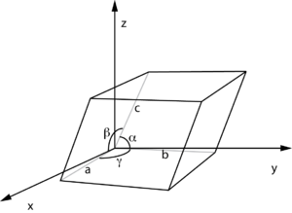The unit cell is characterized by three lattice constants a, b, c (the lengths of the basis vectors or edges of the unit cell) and by the three angles α, β, γ which separate these vectors from one another. α is the angle between the basis vectors **b** and **c**, β between **a** and **c**, and γ between **a** and **b** (fig. 6).

The lattice constants and the angles between them are called lattice parameters.

The volume of a unit cell is given by

***V =***

*Figure 6: Pictorial representation of unit cell.*

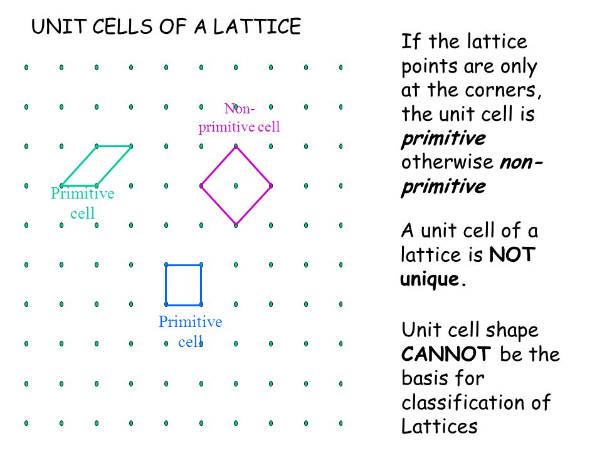**Primitive Cell**

Primitive cell is a unit cell constructed so that it contains only one lattice point. The primitive cell has lattice points only at corners. It does not define the full symmetry of the entire space lattice. There are multiple ways to select a primitive cell (fig.7).

*Figure 7: Multiple ways to select a primitive cell.*

**Non-primitive unit cell**: It has lattice Point at corners as well as at other points.

* + **SYMMETRY**

**Symmetry:** A body is said to be symmetrical when it can be divided into parts that are related to each other in certain ways.

**Symmetry Operation:** An operation that leads to superimposition of an object on itself.

**Symmetry operators**: translation, rotation, reflection, inversion.

**Symmetry Element:** An imaginary geometric entity (line, point, plane) about which a symmetry operation takes place.

**Symmetry elements:** point, line, plane.

**Rotation:** An n-fold rotation symmetry means rotation through an angle of 2π/n will repeat the object or motif n times in a full 360⁰ rotation. n =1 means no symmetry. In a crystal, only 2, 3, 4 and 6-folds of rotation are possible.

**Reflection:** An object with a reflection symmetry will be a mirror image of itself across a plane called mirror plane (m).

**Inversion:** In this operation, every part of the object is reflected through an inversion center called center of symmetry which is denoted as i. The object is reproduced inverted from its original position.

Combined Operations:

1. **Screw Axis**: A screw axis (helical axis or twist axis) is a line that is simultaneously the axis of rotation and the line along which translation of a body occurs.
2. **Glide plane:** A glide plane (or transflection) is a symmetry operation describing how a reflection in a plane, followed by a translation parallel with that plane, may leave the crystal unchanged.
3. **Roto-inversion:** A rotoinversion axis combines rotation about an axis of rotation with inversion.
   * **SEVEN DIFFERENT CRYSTAL SYSTEMS AND FOURTEEN DIFFERENT BRAVAIS LATTICES:**

Crystals are divided into 7 crystal systems according to their geometric symmetries and into 7 lattice systems according to their [Bravais lattices](https://en.wikipedia.org/wiki/Bravais_lattice).

A **lattice system** is generally identified as a set of lattices with the same shape according to the relative lengths of the cell edges (*a*, *b*, *c*) and the angles between them (*α*, *β*, *γ*).

Each lattice is assigned to one of the following classifications (lattice types) based on the positions of the lattice points within the cell: **primitive (P), body-centered (I), face-centered (F), base-centered (A, B, or C), and rhombohedral (R).**

The 14 unique combinations of lattice systems and lattice types are collectively known as the [Bravais lattices](https://en.wikipedia.org/wiki/Bravais_lattice" \o "Bravais lattice).

Thus, solids are classified into 7 crystal systems and 14 Bravais lattices as represented in table 1 and 2.



*Table 1: Classification of solids into 7 crystal systems on the basis of geometric symmetries.*

*Table 2: Classification of solids into 7 crystal systems and 14 Bravais lattices.*

1. **STRUCTURE OF CUBIC CRYSTALS**
   * 2.1 **CUBIC CRYSTAL STRUCTURES**

*Parameters of crystal structure:*

* **Number of atoms per unit cell or Effective number**: It is the total number of atoms per unit cell.
* **Co-ordination number:** It is the number of nearest neighboring atoms to a particular atom in the crystal.
* **Atomic radius:** It is defined as half of the distance between two nearest neighbors in a crystal of a pure element since any two nearest neighboring atoms touch each other. It is usually expressed in terms of the edge of the unit cell ‘a’.
* **Atomic packing factor (Packing density) (APF):** Atomic packing factor (APF) or packing density indicates how closely atoms are packed in a unit cell and is given by the ratio of volume of atoms in the unit cell and volume of the unit cell.

***Simple Cubic Structure***

* **Number of atoms per unit cell or Effective number:**

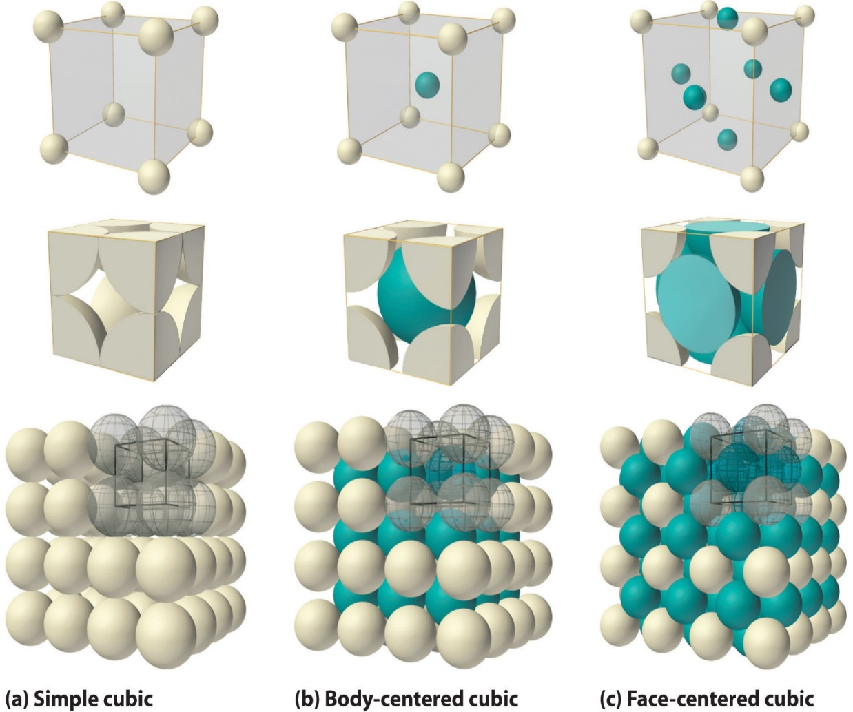

a

R

There are 8 atoms at the eight corners of the unit cell. Each of these atoms are shared by eight unit cells.

Therefore, effective number of atoms in simple cubic unit cell is equal to

**8 (corner atoms) x 1/8 = 1 atom / unit cell.**

* **Co-ordination number:**

Each corner atom is in contact with two other atoms along the edges of the cube.

Hence, the co-ordination number of simple cubic structure is **6**.

* **Atomic radius:**

In a simple cubic structure, the atoms touch each other along the edge of the cube.

Hence, the atomic radius 'R' in terms of the length of the edge of the unit cell 'a' is ***a = 2R*** *Figure 8: Simple Cubic*

*Structure*

* **Atomic Packing Factor**

* 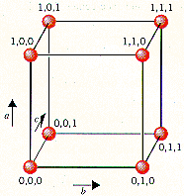**Co-ordinates of atoms in simple cubic structure**.

**Relation between molecular weight, density and lattice parameter**

Cubic lattice parameter a

ρ be the density of the crystal

Volume of the unit cell = a3

Hence mass of each unit cell = ρ * a3

Mass of each molecule = M/N

M = Molecular weight; N = Avogadro number

Hence mass of each unit cell = n * M/N

n = Number of atoms per unit cell

n * M/N = ρ * a3

a3 = nM / ρ N

* ***Body-centered Cubic Structure***



*Figure 9: Body-centered cubic structure*

* **Number of atoms per unit cell or Effective number:**

There are 8 atoms at the eight corners and 1 atom at the center of the unit cell.

Each of the corner atoms are shared by eight unit cells while the center atom entirely belongs to the unit cell.

Hence, the effective number of atoms per unit cell is

**8 (corner atoms) x 1/8 + 1 centre atom = 2 atoms / unit cell.**

* **Co-ordination number:**

The body-centered atom is in contact with all the 8 corner atoms.

Hence, co-ordination number of body-centered cubic structure is **8.**

* 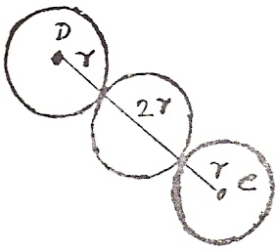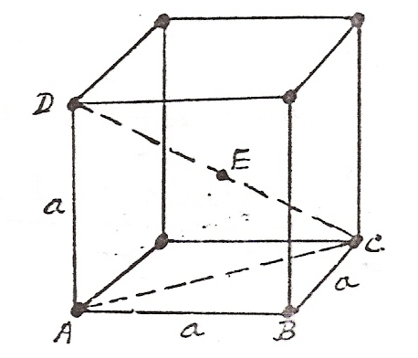**Atomic radius:** In a body-centered cubic structure, the atoms touch each other along the body diagonal of the cube **AB = BC = AD = a**

**CD = 4r**

**From ABC**

**AC2 = AB2 + BC2 = a2 + a2 = 2a2**

**AC2 = 2a2 From ACD**

**CD2 = AC2 + AD2 = 2a2 + a2 = 3a2** *Figure 10*

**(4r)2 = 3a2**

**16r2 = 3a2**

**r2 =3a2/16**

**Atomic radius r =**  a / 4

* 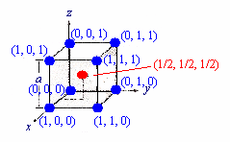**Co-ordinates of atoms in Body center cubic structure**

* **Atomic Packing Factor**

Calculation of APF:



* ***Face-centered Cubic Structure (FCC)***
* **Number of atoms per unit cell or Effective number:**

There are 8 atoms at the eight corners and 6 atom at the centre of each face of the unit cell.

Each of the corner atoms are shared by eight unit cells while the face-centered atoms are shared by 2 unit cells.

Hence, the effective number of atoms per unit cell is

**8 (corner atoms) x 1/8 + 6 (face-centered atoms) x 1/2 = 4 atoms / unit cell.**

* **Co-ordination number:**

The face centered atom in the front face is in contact with four corner atoms and four other face-centered atoms behind it (two sides, top and bottom) and is also touching four face-centered atoms of the unit cell in front of it.

Hence, co-ordination number of FCC is **12**.



*Figure 11: Face-centered cubic structure.*

* **Atomic radius:**

In a face-centered cubic structure, the atoms touch each other along the face diagonal of the cube. Hence, the atomic radius 'R' in terms of the length of the edge of the unit cell 'a' is

From Fig., AB = BC = a and AC = 4r

From ABC

AC2 = AB2 + BC2 = a2 + a2 = 2a2 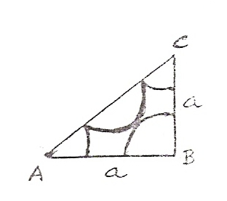

AC = a *Figure 12*

4r = a

Atomic radius = r = a / 4

* **Atomic Packing Factor:**

Calculation of APF:



**Hexagonal Closely Packed Structure(HCP)**

The hexagonal closely packed (hcp) is shown in the figure . In the hcp structure of an unit cell contains three types of atoms as three layers.

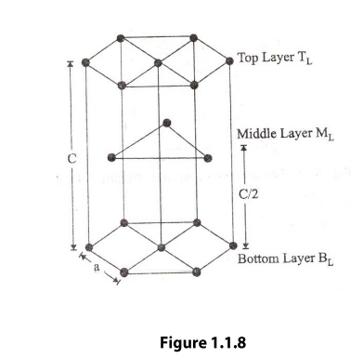

12 corner atoms, one at each and every corner of the Hexagon.

2 base cantered atoms, one at the top face of the hexagon and another at the bottom face of the hexagon.

In addition to corner and base atoms, 3 atoms are situated in between the top and bottom face of the hexagon, in alternate vertical faces. Also note that these atoms are situated inside the face so that they can’t be shared by other cells as shown in the figure

**(i)**                **Number of atoms per unit cell**

To calculate the number of atoms per unit cell, first consider the bottom layer. The bottom layer consists of six corner atoms and one face centered atom. Each and every corner atom contributes 1/6 of its part to one unit cell. The total number atoms contributed by the corner atoms is 1/6 x 6 = 1. The face-centered atom contributes ½ of its part to one unit cell. Therefore, the total number of atoms contributes ½ of its part to one unit cell. Therefore, total number of atoms present in the case of the bottom layer is 1 + ½ = 3/2

Similarly, the number of atoms present in the upper layer is 1 + ½ = 3/2

The number of the atoms present in the middle layer = 1 x 3 = 3

The total number of atoms present in the unit cell = 3/2 + 3/2 + 3  = 6 atoms.

**ii)**             **Atomic Radius**

To find the atomic radius of the hcp structure, consider any two-corner atoms. It has to be noted that, each and every corner atom touches with each other, therefore they are nearest neighbor.

From figure we can write r = ½.

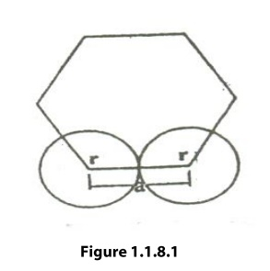

**(iii)**           **Coordination Number**

The coordination number of the hcp structure can be calculated as follows. Let us consider two unit cells as shown in the figure

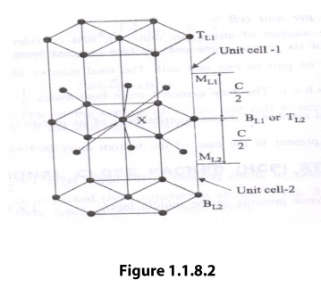

The hcp structure is considered to have three layers viz, 1) Bottom Layer [B1], 2) Top Layer [T1] and 3) Middle Layer [M1] as shown.

In the top and bottom layers, the base cantered atom is surrounded by six corner atoms. In the middle layer we have 3 atoms stacked inside the unit cell as shown. Let us consider two unit cells let ‘X’ be the reference atom taken in the bottom layer BL1 of unit cell 1(or top layer [TL2] of unit cell 2). This atom has 6 neighbouring atom in its own plane. Further at a distance of c/2 it has 3 atoms in the middle layer (ML1) of unit cell -1 and 3 more atoms in the middle layer (ML2) of unit cell -2. Therefore, the total number of neighbouring atoms is 6+3+3=12

Thus the coordination number is 12.

**c/a ratio**

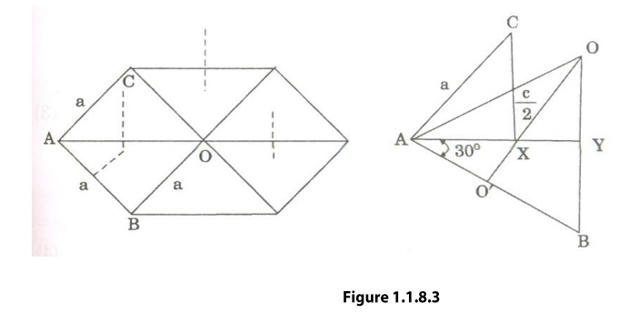

We know that ‘c’ is the height of the unit cell of HCP structure and ‘a’ is the distance between two neighbouring atoms. Now consider a triangle ABO in the bottom layer.

Here A,B, and O are the lattice points and exactly above these atoms at a perpendicular distance ‘c’/2 the next layer atom lies at C.

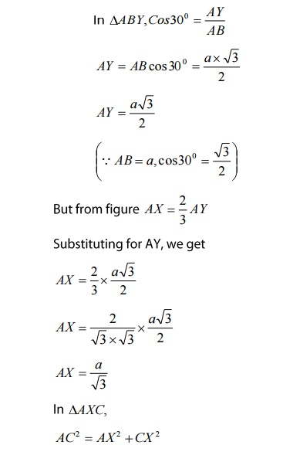

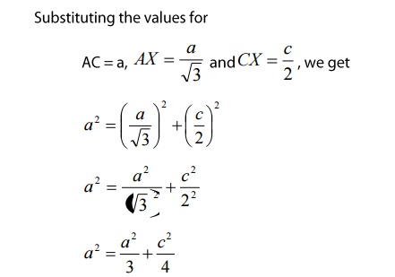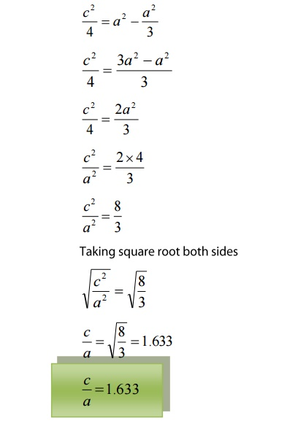

**(iv)**           **Atomic Packing factor**

Volume of all atoms in a unit cell(v)

Atomic radius r = a/2

No of atoms per unit cell, n =6

Volume of all the six atoms in the unit cell

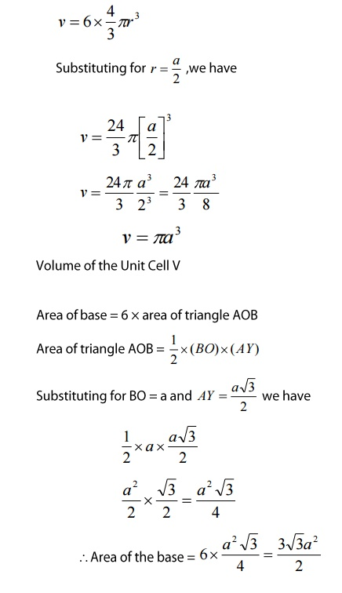

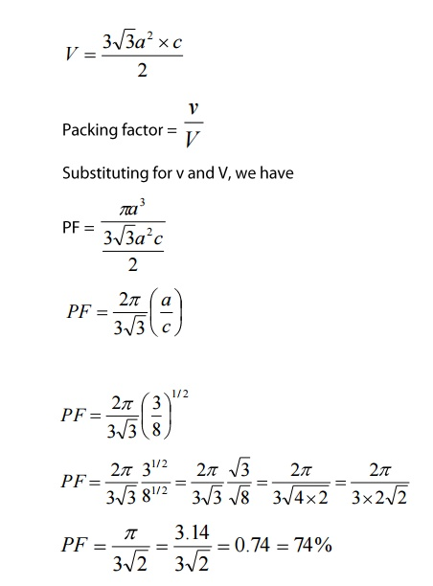

Thus the packing density is 74% and hence, it is a closed packed structure.

Example. Zinc, Beryellium and Magnesium